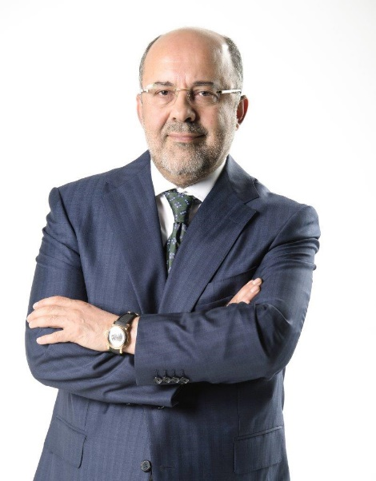
MEHMET SOYSAL
Executive Board Member & Chief Executive Officer

He was born in Elazığ in 1964. He completed his undergraduate education in Marmara University at the Faculty of Fine Arts and in A.U. Public Administration at the Faculty of Economics and then he completed his studies on Political Science at Preston University and on Law at European University ...
Soysal, who began his profession in Turkiye Newspaper in 1983, worked as a cultural-art correspondent, editor, war correspondent, national news chief and director.
In 1992, he worked as an assistant news director in the foundation of TGRT. At the same time, he prepared and presented documentaries called İz Bırakanlar, Nereden Nereye and Kızıl Güneş.
Soysal, who became the Executive Editor of TGRT in 1999, maintained this position for 12 years without interruption.
Dating from 2005, he continued to write as a columnist for Turkiye newspaper.
Soysal, who prepared and presented the program titled Baş Başa in TGRT and TGRT News TV for 17 years, wrote three different books...
Soysal, who also served as the General Director of TGRT Haber TV and as the Vice Chairman of the Board of Directors of Ihlas Holding, in 2010, he took on the position as the Board Member and Deputy Chairman of BJK.
Soysal, who became the Chief Advisor to the Demirören Media Group in 2013, also served as a columnist at Vatan Newspaper for two years..
Soysal, who started to write opinion columns at Milliyet Newspaper in 2016, maintains to serve simultaneously as the Chairman of the Executive Board of Milliyet and Vatan Newspapers.
He became the Board Member of Demirören Medya Holding which has become Turkey's leading media group along with joining of the brands of Hürriyet, Posta, Fanatik, Kanal D, CNN Türk, Teve2, Dream and D-Smart to the group in 2018 and also the Chief Executive Officer of all the companies at the same time.

